C PROGRAMMING
NAME : VISHAAL G
REG NO : 1921260043
COURSE CODE : CSA0222
Task 7: Control Type Conversion and Precision (4 marks)
7.1 Type conversion
- Implicit conversion: C automatically converts operands when different types are combined.
- Integer promotion: Types smaller than int, such as short, are commonly promoted to int before arithmetic.
- Explicit casting: The programmer converts a value using a cast, such as (long)units.
- Integer division: Dividing two integers discards the fractional part.
- Narrowing conversion: Converting a large long to int may lose information or produce an implementation-defined result if the value is not representable.
7.2 Three unexpected expressions
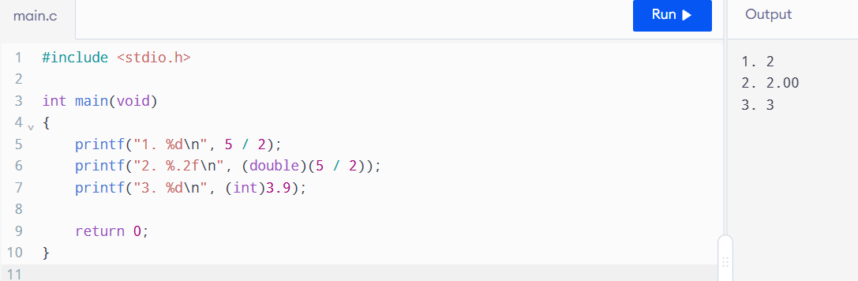

Explanation:
- 5 / 2 gives 2 because both operands are integers.
- (double)(5 / 2) still gives 2.00 because division happens before casting.
- (int)3.9 gives 3 because conversion to an integer discards the fractional part.

7.3 Rounding money
If a fractional charge must be converted to paise, use a consistent rounding rule. For example, rounding ₹12.345 to two decimal places using round-half-up gives ₹12.35.
For tariffs already specified in paise, integer arithmetic avoids this extra rounding step.

7.4 Alternative: floating-point calculation
A floating-point design can calculate charges in rupees and round each final bill to paise. However, small representation errors can accumulate when thousands of bills are added.
Both approaches require \(O(1)\) time and fixed space per value. Integer paise is preferred for exact monetary totals, provided overflow is prevented.

